TABEL t, r, F, , dan Z
Tabel t – student (atas 2phk, bawah 1 phk)
Db/Dk/Df | Taraf Alpha
 | 0.50 | 0.45 | 0.40 | 0.35 | 0.30 | 0.25 | 0.20 | 0.15 | 0.10 | 0.05 | Atas  2 PIHAK  Batas (1%):  - / + 63,66  Batas (5%):  - / + 12,71  Bawah  1 PIHAK  Batas (1%):  - / + 31,82  Batas (5%):  - / + 6,31  0.025
 | 0.25 | 0.225 | 0.20 | 0.175 | 0.15 | 0.125 | 0.10 | 0.075 | 0.05 | 0.025 | 0.0125
1 | 1.000 | 1.171 | 1.376 | 1.632 | 1.963 | 2.414 | 3.078 | 4.165 | 6.314 | 12.706 | 25.452
2 | 0.816 | 0.931 | 1.061 | 1.210 | 1.386 | 1.604 | 1.886 | 2.282 | 2.920 | 4.303 | 6.205
3 | 0.765 | 0.866 | 0.978 | 1.105 | 1.250 | 1.423 | 1.638 | 1.924 | 2.353 | 3.182 | 4.177
4 | 0.741 | 0.836 | 0.941 | 1.057 | 1.190 | 1.344 | 1.533 | 1.778 | 2.132 | 2.776 | 3.495
5 | 0.727 | 0.819 | 0.920 | 1.031 | 1.156 | 1.301 | 1.476 | 1.699 | 2.015 | 2.571 | 3.163
6 | 0.718 | 0.808 | 0.906 | 1.013 | 1.134 | 1.273 | 1.440 | 1.650 | 1.943 | 2.447 | 2.969
7 | 0.711 | 0.800 | 0.896 | 1.001 | 1.119 | 1.254 | 1.415 | 1.617 | 1.895 | 2.365 | 2.841
8 | 0.706 | 0.794 | 0.889 | 0.993 | 1.108 | 1.240 | 1.397 | 1.592 | 1.860 | 2.306 | 2.752
9 | 0.703 | 0.790 | 0.883 | 0.986 | 1.100 | 1.230 | 1.383 | 1.574 | 1.833 | 2.262 | 2.685
10 | 0.700 | 0.786 | 0.879 | 0.980 | 1.093 | 1.221 | 1.372 | 1.559 | 1.812 | 2.228 | 2.634
11 | 0.697 | 0.783 | 0.876 | 0.976 | 1.088 | 1.214 | 1.363 | 1.548 | 1.796 | 2.201 | 2.593
12 | 0.695 | 0.781 | 0.873 | 0.972 | 1.083 | 1.209 | 1.356 | 1.538 | 1.782 | 2.179 | 2.560
13 | 0.694 | 0.779 | 0.870 | 0.969 | 1.079 | 1.204 | 1.350 | 1.530 | 1.771 | 2.160 | 2.533
14 | 0.692 | 0.777 | 0.868 | 0.967 | 1.076 | 1.200 | 1.345 | 1.523 | 1.761 | 2.145 | 2.510
15 | 0.691 | 0.776 | 0.866 | 0.965 | 1.074 | 1.197 | 1.341 | 1.517 | 1.753 | 2.131 | 2.490
16 | 0.690 | 0.774 | 0.865 | 0.963 | 1.071 | 1.194 | 1.337 | 1.512 | 1.746 | 2.120 | 2.473
17 | 0.689 | 0.773 | 0.863 | 0.961 | 1.069 | 1.191 | 1.333 | 1.508 | 1.740 | 2.110 | 2.458
18 | 0.688 | 0.772 | 0.862 | 0.960 | 1.067 | 1.189 | 1.330 | 1.504 | 1.734 | 2.101 | 2.445
19 | 0.688 | 0.771 | 0.861 | 0.958 | 1.066 | 1.187 | 1.328 | 1.500 | 1.729 | 2.093 | 2.433
20 | 0.687 | 0.771 | 0.860 | 0.957 | 1.064 | 1.185 | 1.325 | 1.497 | 1.725 | 2.086 | 2.423
21 | 0.686 | 0.770 | 0.859 | 0.956 | 1.063 | 1.183 | 1.323 | 1.494 | 1.721 | 2.080 | 2.414
22 | 0.686 | 0.769 | 0.858 | 0.955 | 1.061 | 1.182 | 1.321 | 1.492 | 1.717 | 2.074 | 2.405
23 | 0.685 | 0.769 | 0.858 | 0.954 | 1.060 | 1.180 | 1.319 | 1.489 | 1.714 | 2.069 | 2.398
24 | 0.685 | 0.768 | 0.857 | 0.953 | 1.059 | 1.179 | 1.318 | 1.487 | 1.711 | 2.064 | 2.391
25 | 0.684 | 0.767 | 0.856 | 0.952 | 1.058 | 1.178 | 1.316 | 1.485 | 1.708 | 2.060 | 2.385
26 | 0.684 | 0.767 | 0.856 | 0.952 | 1.058 | 1.177 | 1.315 | 1.483 | 1.706 | 2.056 | 2.379
27 | 0.684 | 0.767 | 0.855 | 0.951 | 1.057 | 1.176 | 1.314 | 1.482 | 1.703 | 2.052 | 2.373
28 | 0.683 | 0.766 | 0.855 | 0.950 | 1.056 | 1.175 | 1.313 | 1.480 | 1.701 | 2.048 | 2.368
29 | 0.683 | 0.766 | 0.854 | 0.950 | 1.055 | 1.174 | 1.311 | 1.479 | 1.699 | 2.045 | 2.364
30 | 0.683 | 0.765 | 0.854 | 0.949 | 1.055 | 1.173 | 1.310 | 1.477 | 1.697 | 2.042 | 2.360
40 | 0.681 | 0.763 | 0.851 | 0.946 | 1.050 | 1.167 | 1.303 | 1.468 | 1.684 | 2.021 | 2.329
50 | 0.679 | 0.761 | 0.849 | 0.943 | 1.047 | 1.164 | 1.299 | 1.462 | 1.676 | 2.009 | 2.311
60 | 0.679 | 0.760 | 0.848 | 0.942 | 1.045 | 1.162 | 1.296 | 1.458 | 1.671 | 2.000 | 2.299
70 | 0.678 | 0.760 | 0.847 | 0.941 | 1.044 | 1.160 | 1.294 | 1.456 | 1.667 | 1.994 | 2.291
80 | 0.678 | 0.759 | 0.846 | 0.940 | 1.043 | 1.159 | 1.292 | 1.453 | 1.664 | 1.990 | 2.284
90 | 0.677 | 0.759 | 0.846 | 0.939 | 1.042 | 1.158 | 1.291 | 1.452 | 1.662 | 1.987 | 2.280
100 | 0.677 | 0.758 | 0.845 | 0.939 | 1.042 | 1.157 | 1.290 | 1.451 | 1.660 | 1.984 | 2.276
110 | 0.677 | 0.758 | 0.845 | 0.939 | 1.041 | 1.156 | 1.289 | 1.450 | 1.659 | 1.982 | 2.272
120 | 0.677 | 0.758 | 0.845 | 0.938 | 1.041 | 1.156 | 1.289 | 1.449 | 1.658 | 1.980 | 2.270
130 | 0.676 | 0.758 | 0.844 | 0.938 | 1.041 | 1.156 | 1.288 | 1.448 | 1.657 | 1.978 | 2.268
140 | 0.676 | 0.758 | 0.844 | 0.938 | 1.040 | 1.155 | 1.288 | 1.447 | 1.656 | 1.977 | 2.266
150 | 0.676 | 0.757 | 0.844 | 0.938 | 1.040 | 1.155 | 1.287 | 1.447 | 1.655 | 1.976 | 2.264
200 | 0.676 | 0.757 | 0.843 | 0.937 | 1.039 | 1.154 | 1.286 | 1.445 | 1.653 | 1.972 | 2.258
300 | 0.675 | 0.756 | 0.843 | 0.936 | 1.038 | 1.153 | 1.284 | 1.443 | 1.650 | 1.968 | 2.253

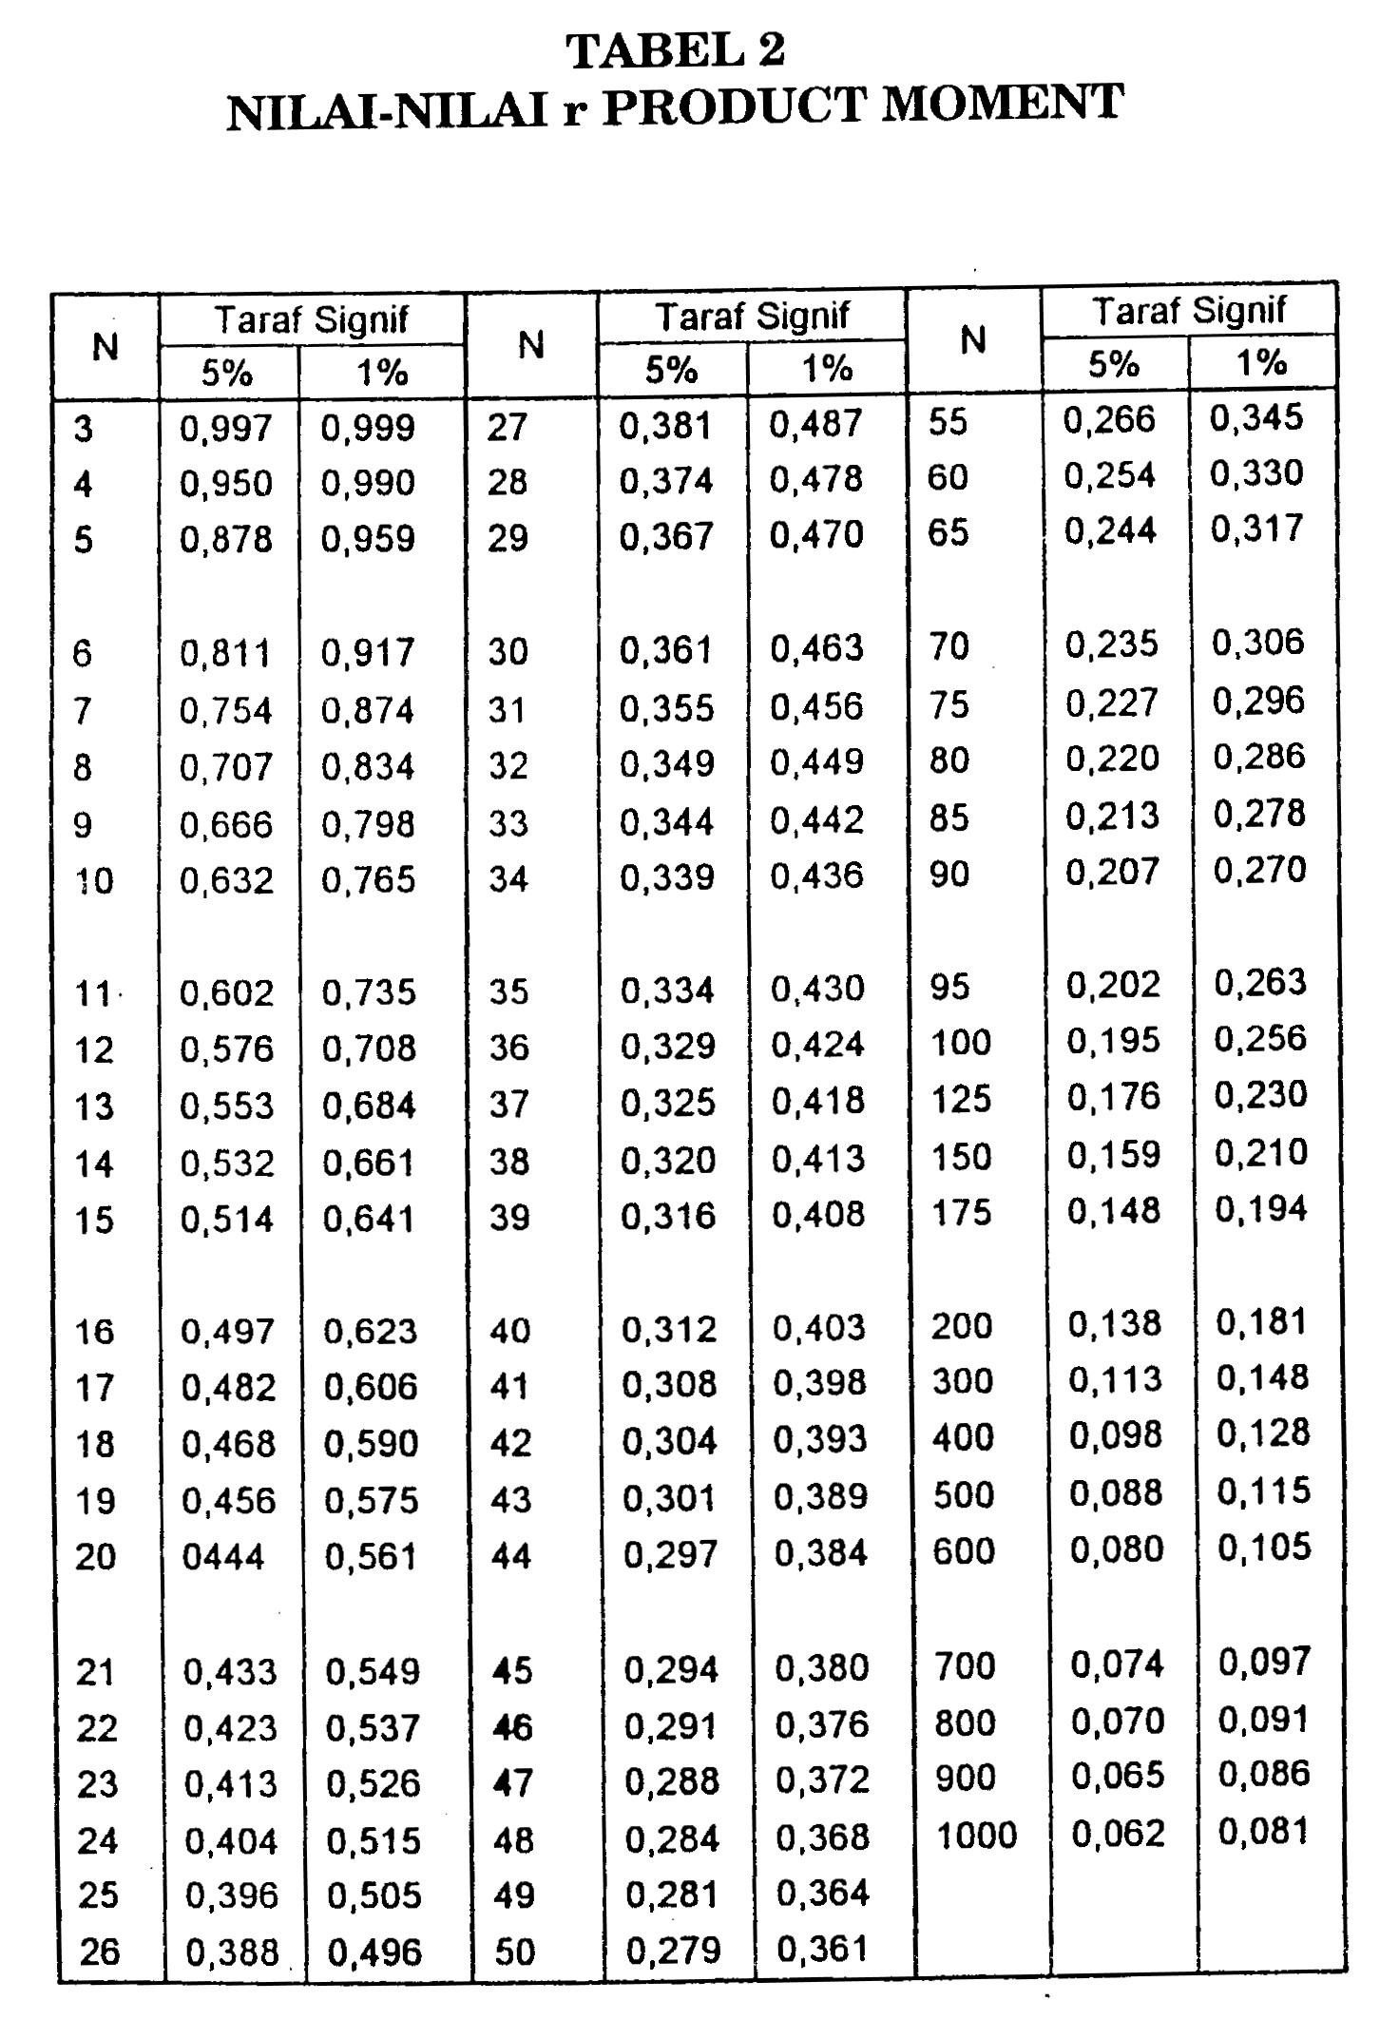

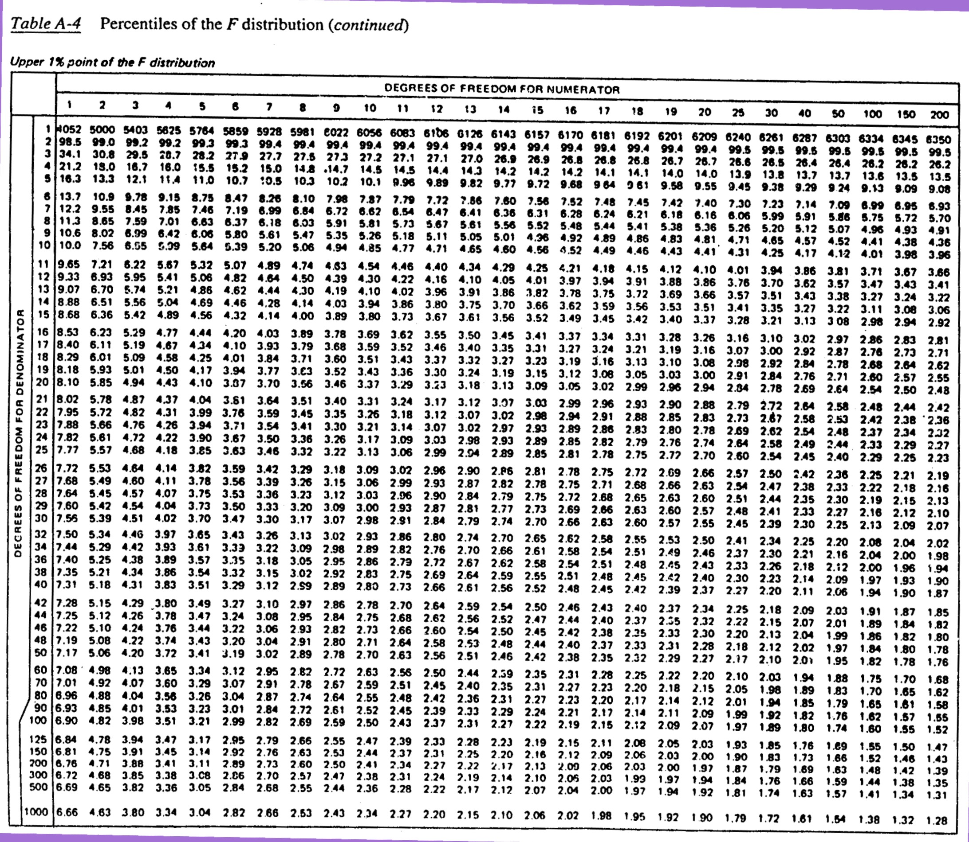

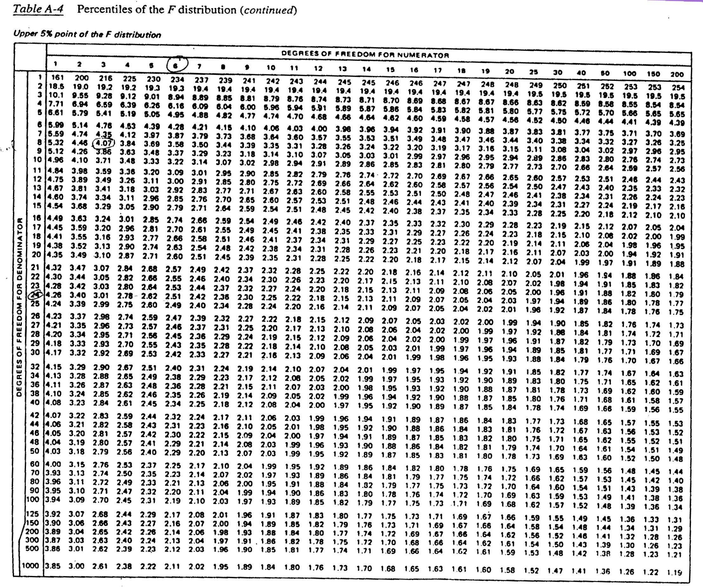

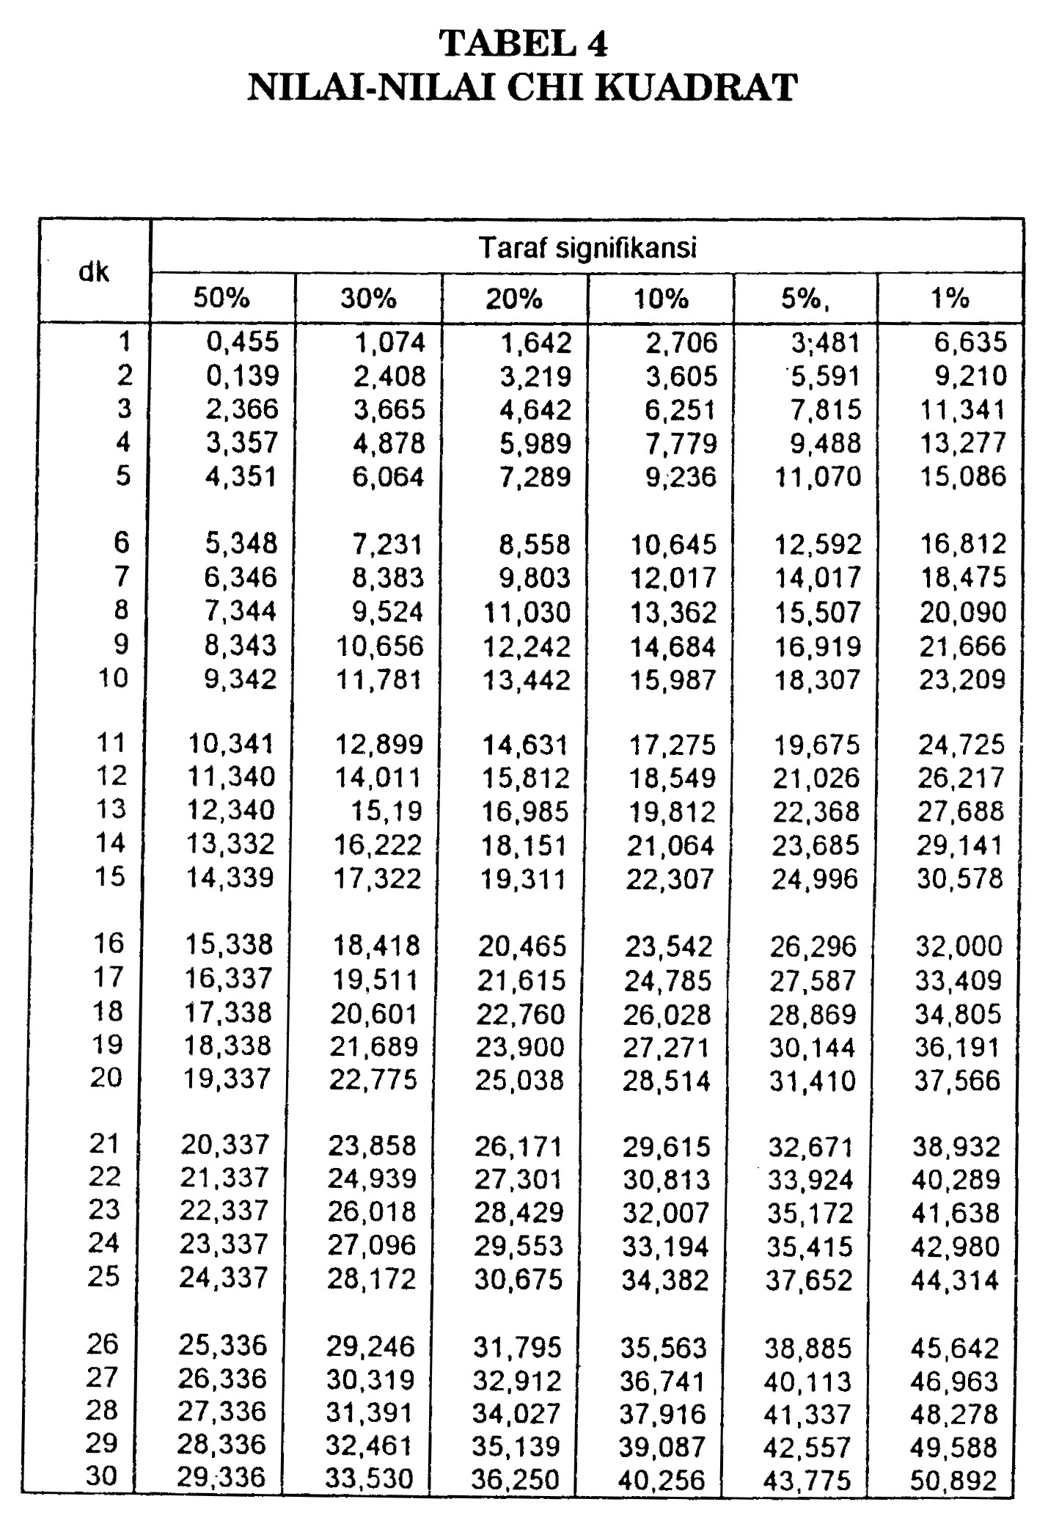

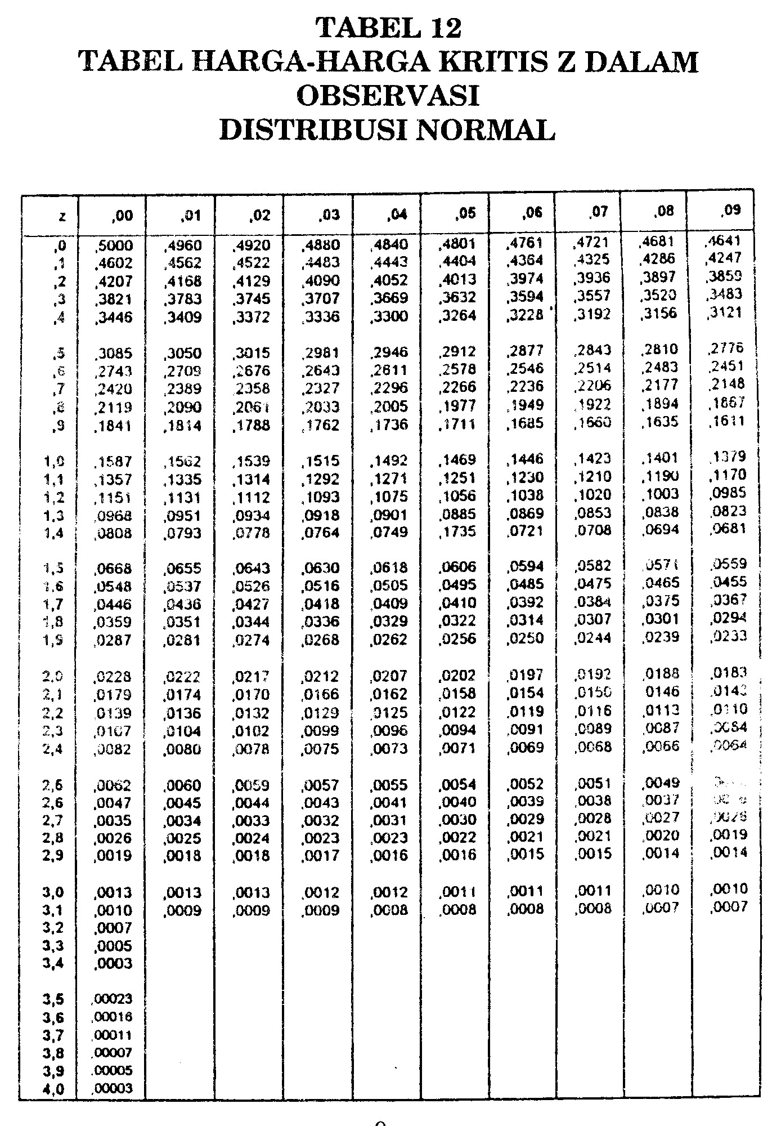
Ini adalah luas kurva 0.500 (50%) pada saat z= 0.00
z-Score Chart
Use this chart to find the area under a normal curve when finding
an approximation for a binomial distribution.
Negative z-score - value is to the left of the mean.
Positive z-score - value is to the right of the mean.
Negative z-scores:
Ini adalah luas kurva 0.0003 (0.003%) pada saat z= -3.42
z | 0.09 | 0.08 | 0.07 | 0.06 | 0.05 | 0.04 | 0.03 | 0.02 | 0.01 | 0.0
-3.4 | 0.0002 | 0.0003 | 0.0003 | 0.0003 | 0.0003 | 0.0003 | 0.0003 | 0.0003 | 0.0003 | 0.0003
-3.3 | 0.0003 | 0.0004 | 0.0004 | 0.0004 | 0.0004 | 0.0004 | 0.0004 | 0.0005 | 0.0005 | 0.0005
-3.2 | 0.0005 | 0.0005 | 0.0005 | 0.0006 | 0.0006 | 0.0006 | 0.0006 | 0.0006 | 0.0007 | 0.0007
-3.1 | 0.0007 | 0.0007 | 0.0008 | 0.0008 | 0.0008 | 0.0008 | 0.0009 | 0.0009 | 0.0009 | 0.0010
-3.0 | 0.0010 | 0.0010 | 0.0011 | 0.0011 | 0.0011 | 0.0012 | 0.0012 | 0.0013 | 0.0013 | 0.0013
-2.9 | 0.0014 | 0.0014 | 0.0015 | 0.0015 | 0.0016 | 0.0016 | 0.0017 | 0.0018 | 0.0018 | 0.0019
-2.8 | 0.0019 | 0.0020 | 0.0021 | 0.0021 | 0.0022 | 0.0023 | 0.0023 | 0.0024 | 0.0025 | 0.0026
-2.7 | 0.0026 | 0.0027 | 0.0028 | 0.0029 | 0.0030 | 0.0031 | 0.0032 | 0.0033 | 0.0034 | 0.0035
-2.6 | 0.0036 | 0.0037 | 0.0038 | 0.0039 | 0.0040 | 0.0041 | 0.0043 | 0.0044 | 0.0045 | 0.0047
-2.5 | 0.0048 | 0.0049 | 0.0051 | 0.0052 | 0.0054 | 0.0055 | 0.0057 | 0.0059 | 0.0060 | 0.0062
-2.4 | 0.0064 | 0.0066 | 0.0068 | 0.0069 | 0.0071 | 0.0073 | 0.0075 | 0.0078 | 0.0080 | 0.0082
-2.3 | 0.0084 | 0.0087 | 0.0089 | 0.0091 | 0.0094 | 0.0096 | 0.0099 | 0.0102 | 0.0104 | 0.0107
-2.2 | 0.0110 | 0.0113 | 0.0116 | 0.0119 | 0.0122 | 0.0125 | 0.0129 | 0.0132 | 0.0136 | 0.0139
-2.1 | 0.0143 | 0.0146 | 0.0150 | 0.0154 | 0.0158 | 0.0162 | 0.0166 | 0.0170 | 0.0174 | 0.0179
-2.0 | 0.0183 | 0.0188 | 0.0192 | 0.0197 | 0.0202 | 0.0207 | 0.0212 | 0.0217 | 0.0222 | 0.0228
-1.9 | 0.0233 | 0.0239 | 0.0244 | 0.0250 | 0.0256 | 0.0262 | 0.0268 | 0.0274 | 0.0281 | 0.0287
-1.8 | 0.0294 | 0.0301 | 0.0307 | 0.0314 | 0.0322 | 0.0329 | 0.0336 | 0.0344 | 0.0351 | 0.0359
-1.7 | 0.0367 | 0.0375 | 0.0384 | 0.0392 | 0.0401 | 0.0409 | 0.0418 | 0.0427 | 0.0436 | 0.0446
-1.6 | 0.0455 | 0.0465 | 0.0475 | 0.0485 | 0.0495 | 0.0505 | 0.0516 | 0.0526 | 0.0537 | 0.0548
-1.5 | 0.0559 | 0.0571 | 0.0582 | 0.0594 | 0.0606 | 0.0618 | 0.0630 | 0.0643 | 0.0655 | 0.0668
-1.4 | 0.0681 | 0.0694 | 0.0708 | 0.0721 | 0.0735 | 0.0749 | 0.0764 | 0.0778 | 0.0793 | 0.0808
-1.3 | 0.0823 | 0.0838 | 0.0853 | 0.0869 | 0.0885 | 0.0901 | 0.0918 | 0.0934 | 0.0951 | 0.0968
-1.2 | 0.0985 | 0.1003 | 0.1020 | 0.1038 | 0.1056 | 0.1075 | 0.1093 | 0.1112 | 0.1131 | 0.1151
-1.1 | 0.1170 | 0.1190 | 0.1210 | 0.1230 | 0.1251 | 0.1271 | 0.1292 | 0.1314 | 0.1335 | 0.1357
-1.0 | 0.1379 | 0.1401 | 0.1423 | 0.1446 | 0.1469 | 0.1492 | 0.1515 | 0.1539 | 0.1562 | 0.1587
-0.9 | 0.1611 | 0.1635 | 0.1660 | 0.1685 | 0.1711 | 0.1736 | 0.1762 | 0.1788 | 0.1814 | 0.1841
-0.8 | 0.1867 | 0.1894 | 0.1922 | 0.1949 | 0.1977 | 0.2005 | 0.2033 | 0.2061 | 0.2090 | 0.2119
-0.7 | 0.2148 | 0.2177 | 0.2206 | 0.2236 | 0.2266 | 0.2296 | 0.2327 | 0.2358 | 0.2389 | 0.2420
-0.6 | 0.2451 | 0.2483 | 0.2514 | 0.2546 | 0.2578 | 0.2611 | 0.2643 | 0.2676 | 0.2709 | 0.2743
-0.5 | 0.2776 | 0.2810 | 0.2843 | 0.2877 | 0.2912 | 0.2946 | 0.2981 | 0.3015 | 0.3050 | 0.3085
-0.4 | 0.3121 | 0.3156 | 0.3192 | 0.3228 | 0.3264 | 0.3300 | 0.3336 | 0.3372 | 0.3409 | 0.3446
-0.3 | 0.3483 | 0.3520 | 0.3557 | 0.3594 | 0.3632 | 0.3669 | 0.3707 | 0.3745 | 0.3783 | 0.3821
-0.2 | 0.3829 | 0.3897 | 0.3936 | 0.3974 | 0.4013 | 0.4052 | 0.4090 | 0.4129 | 0.4168 | 0.4207
-0.1 | 0.4247 | 0.4286 | 0.4325 | 0.4364 | 0.4404 | 0.4443 | 0.4483 | 0.4522 | 0.4562 | 0.4602
-0.0 | 0.4641 | 0.4681 | 0.4721 | 0.4761 | 0.4801 | 0.4840 | 0.4880 | 0.4920 | 0.4960 | 0.5000

Positive z-scores:
z | 0.0 | 0.01 | 0.02 | 0.03 | 0.04 | 0.05 | 0.06 | 0.07 | 0.08 | 0.09
0.0 | 0.5000 | 0.5040 | 0.5080 | 0.5120 | 0.5160 | 0.5199 | 0.5239 | 0.5279 | 0.5319 | 0.5359
0.1 | 0.5398 | 0.5438 | 0.5478 | 0.5517 | 0.5557 | 0.5596 | 0.5636 | 0.5675 | 0.5714 | 0.5753
0.2 | 0.5793 | 0.5832 | 0.5871 | 0.5910 | 0.5948 | 0.5987 | 0.6026 | 0.6064 | 0.6103 | 0.6141
0.3 | 0.6179 | 0.6217 | 0.6255 | 0.6293 | 0.6331 | 0.6368 | 0.6406 | 0..6443 | 0.6480 | 0.6517
0.4 | 0.6554 | 0.6591 | 0.6628 | 0.6664 | 0.6700 | 0.6736 | 0.6772 | 0.6808 | 0.6844 | 0.6879
0.5 | 0.6915 | 0.6950 | 0.6985 | 0.7019 | 0.7054 | 0.7088 | 0.7123 | 0.7157 | 0.7190 | 0.7224
0.6 | 0.7257 | 0.7291 | 0.7324 | 0.7357 | 0.7389 | 0.7422 | 0.7454 | 0.7486 | 0.7517 | 0.7549
0.7 | 0.7580 | 0.7611 | 0.7642 | 0.7673 | 0.7704 | 0.7734 | 0.7764 | 0.7794 | 0.7823 | 0.7852
0.8 | 0.7881 | 0.7910 | 0.7939 | 0.7967 | 0.7995 | 0.8023 | 0.8051 | 0.8078 | 0.8106 | 0.8133
0.9 | 0.8159 | 0.8186 | 0.8212 | 0.8238 | 0.8264 | 0.8289 | 0.8315 | 0.8340 | 0.8365 | 0.8389
1.0 | 0.8413 | 0.8438 | 0.8461 | 0.8485 | 0.8508 | 0.8531 | 0.8554 | 0.8577 | 0.8599 | 0.8621
1.1 | 0.8643 | 0.8665 | 0.8686 | 0.8708 | 0.8729 | 0.8749 | 0.8770 | 0.8790 | 0.8810 | 0.8830
1.2 | 0.8849 | 0.8869 | 0.8888 | 0.8907 | 0.8925 | 0.8944 | 0.8962 | 0.8980 | 0.8997 | 0.9015
1.3 | 0.9032 | 0.9049 | 0.9066 | 0.9082 | 0.9099 | 0.9115 | 0.9131 | 0.9147 | 0.9162 | 0.9177
1.4 | 0.9192 | 0.9207 | 0.9222 | 0.9236 | 0.9251 | 0.9265 | 0.9279 | 0.9292 | 0.9306 | 0.9319
1.5 | 0.9332 | 0.9345 | 0.9357 | 0.9370 | 0.9382 | 0.9394 | 0.9406 | 0.9418 | 0.9429 | 0.9441
1.6 | 0.9452 | 0.9463 | 0.9474 | 0.9484 | 0.9495 | 0.9505 | 0.9515 | 0.9525 | 0.9535 | 0.9545
1.7 | 0.9554 | 0.9564 | 0.9573 | 0.9582 | 0.9591 | 0.9599 | 0.9608 | 0.9616 | 0.9625 | 0.9633
1.8 | 0.9641 | 0.9649 | 0.9656 | 0.9664 | 0.9671 | 0.9678 | 0.9686 | 0.9693 | 0.9699 | 0.9706
1.9 | 0.9713 | 0.9719 | 0.9726 | 0.9732 | 0.9738 | 0.9744 | 0.9750 | 0.9756 | 0.9761 | 0.9767
2.0 | 0.9772 | 0.9778 | 0.9783 | 0.9788 | 0.9793 | 0.9798 | 0.9803 | 0.9808 | 0.9812 | 0.9817
2.1 | 0.9821 | 0.9826 | 0.9830 | 0.9834 | 0.9838 | 0.9842 | 0.9846 | 0.9850 | 0.9854 | 0.9857
2.2 | 0.9861 | 0.9864 | 0.9868 | 0.9871 | 00.9875 | 0.9878 | 0.9881 | 0.9884 | 0.9887 | 0.9890
2.3 | 0.9893 | 0.9896 | 0.9898 | 0.9901 | 0.9904 | 0.9906 | 0.9909 | 0.9911 | 0.9913 | 0.9916
2.4 | 0.9918 | 0.9920 | 0.9922 | 0.9925 | 0.9927 | 0.9929 | 0.9931 | 0.9932 | 0.9934 | 0.9936
2.5 | 0.9938 | 0.9940 | 0.9941 | 0.9943 | 0.9945 | 0.9946 | 0.9948 | 0.9949 | 0.9951 | 0.9952
2.6 | 0.9953 | 0.9955 | 0.9956 | 0.9957 | 0.9959 | 0.9960 | 0.9961 | 0.9962 | 0.9963 | 0.9964
2.7 | 0.9965 | 0.9966 | 0.9967 | 0.9968 | 0.9969 | 0.9970 | 0.9971 | 0.9972 | 0.9973 | 0.9974
2.8 | 0.9974 | 0.9975 | 0.9976 | 0.9977 | 0.9977 | 0.9978 | 0.9979 | 0.9979 | 0.9980 | 0.9981
2.9 | 0.9981 | 0.9982 | 0.9982 | 0.9983 | 0.9984 | 0.9984 | 0.9985 | 0.9985 | 0.9986 | 0.9986
3.0 | 0.9987 | 0.9987 | 0.9987 | 0.9988 | 0.9988 | 0.9989 | 0.9989 | 0.9989 | 0.9990 | 0.9990
3.1 | 0.9990 | 0.9991 | 0.9991 | 0.9991 | 0.9992 | 0.9992 | 0.9992 | 0.9992 | 0.9993 | 0.9993
3.2 | 0.9993 | 0.9993 | 0.9994 | 0.9994 | 0.9994 | 0.9994 | 0.9994 | 0.9995 | 0.9995 | 0.9995
3.3 | 0.9995 | 0.9995 | 0.9995 | 0.9996 | 0.9996 | 0.9996 | 0.9996 | 0.9996 | 0.9996 | 0.9997
3.4 | 0.9997 | 0.9997 | 0.9997 | 0.9997 | 0.9997 | 0.9997 | 0.9997 | 0.9997 | 0.9997 | 0.9998

